User Management
User’s Guide



Table of Contents
1. Overview……………………………………………………………………………………………………………………….3
2. Features………………………………………………………………………………………………………………………..3
2.1 Login and Navigation……………………………………………………………………………………………………3
2.2 User Management………………….……………………………………………………………………………………3
2.2.1 Create User………………………………………………………………………………….........................4
2.2.2 Change Password…………………………………………………………………………………….………….5
2.2.3 User History………………………………………………………………………………………………………..6
2.3 Logout………………………………………………………………………………………………………………….…...7

1. Overview
The User Management section in XCO helps to manage users by allowing you to Create new users, Change Passwords, and Activate or Deactivate users.
2. Features
2.1 Login and Navigation
Login to the XCO application.
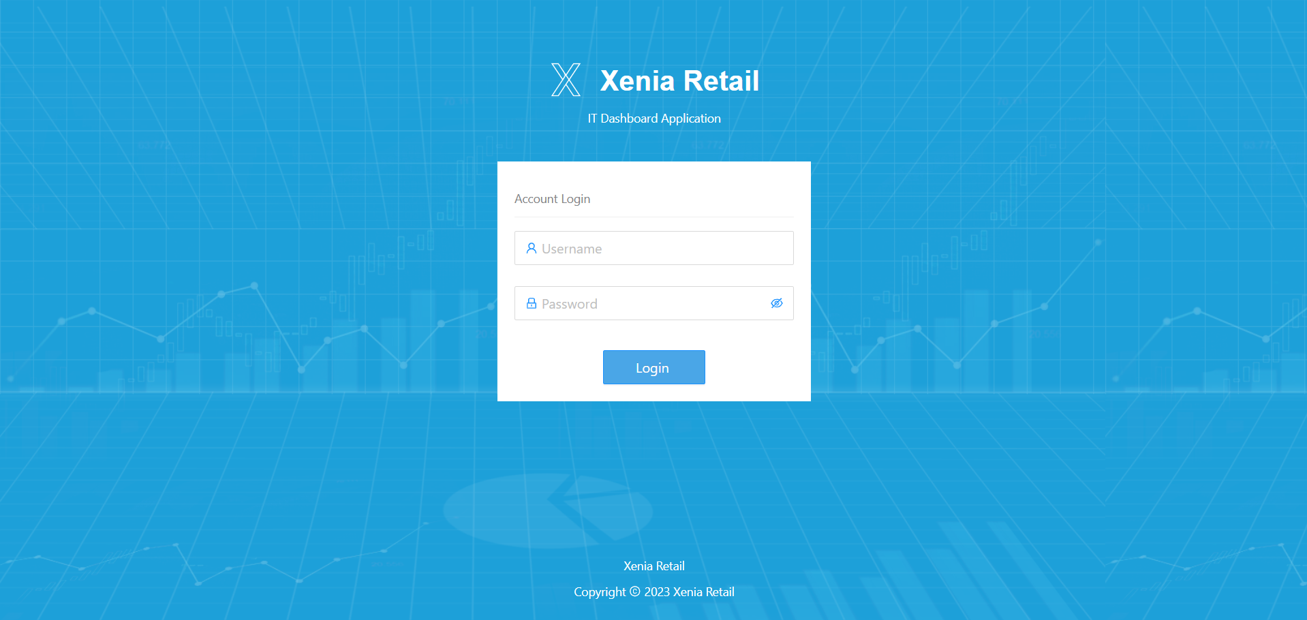
Navigate to the User Management dropdown.
2.2 User Management
You will see the following options: Create User, Change Password, User History
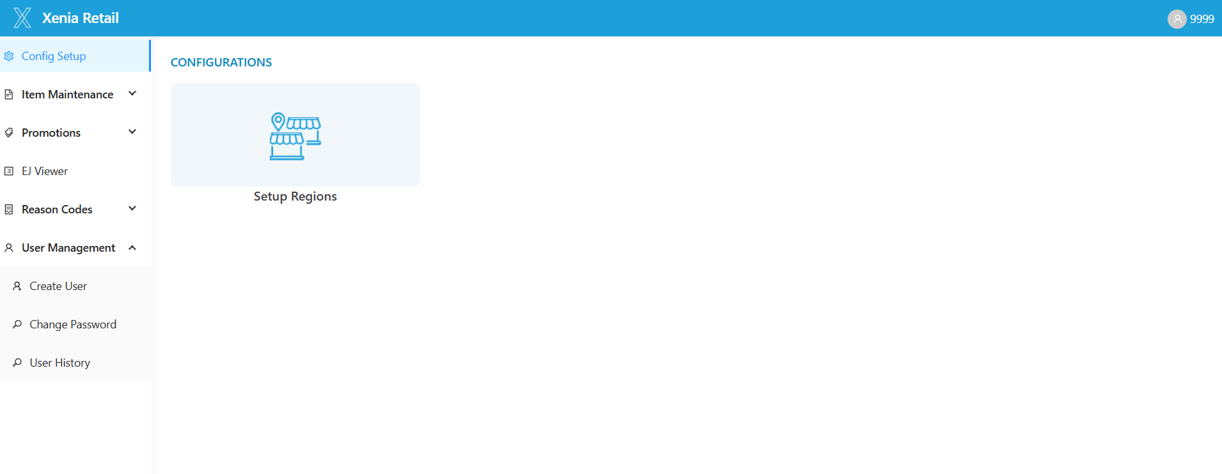
2.2.1 Create User
Click on Create User.
The Create User page will appear with the following fields:
- First Name
- Middle Name (optional)
- Last Name
- Username (Enter email address)
- Password (All numeric, 8 to 10 digits)
- Confirm Password (Same as above)
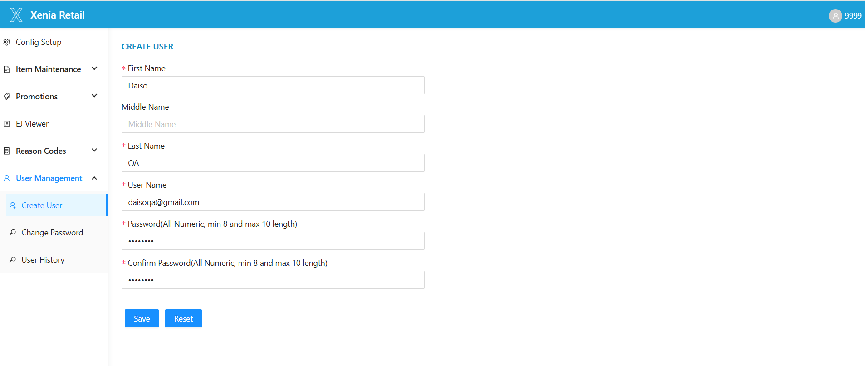
Click on Save to create the user or Reset to clear the fields.
After filling all required fields, the user will be created successfully.
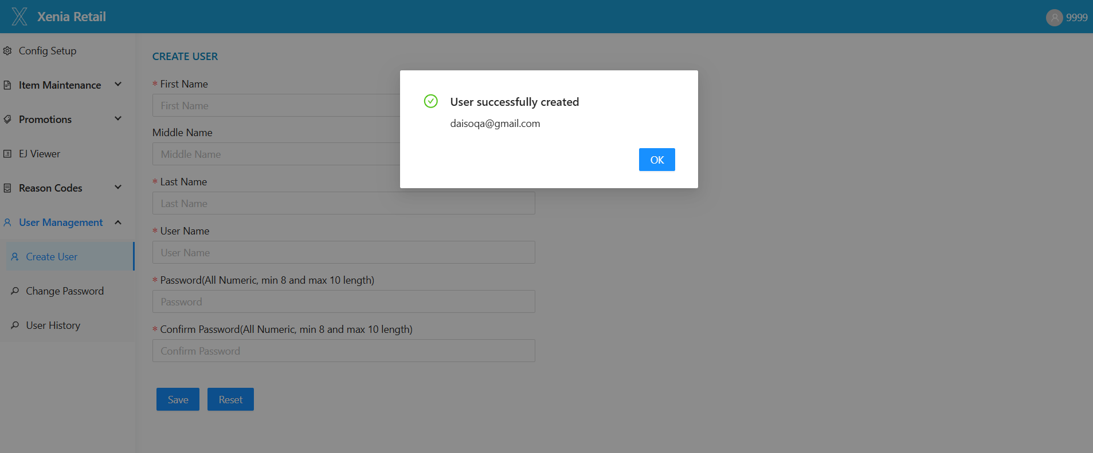
2.2.2 Change Password
Click on Change Password.
The page will have the following fields:
- Username (Disabled, cannot be changed)
- Old Password
- New Password (All numeric, 8 to 10 digits)
- Confirm Password (Same as New Password)
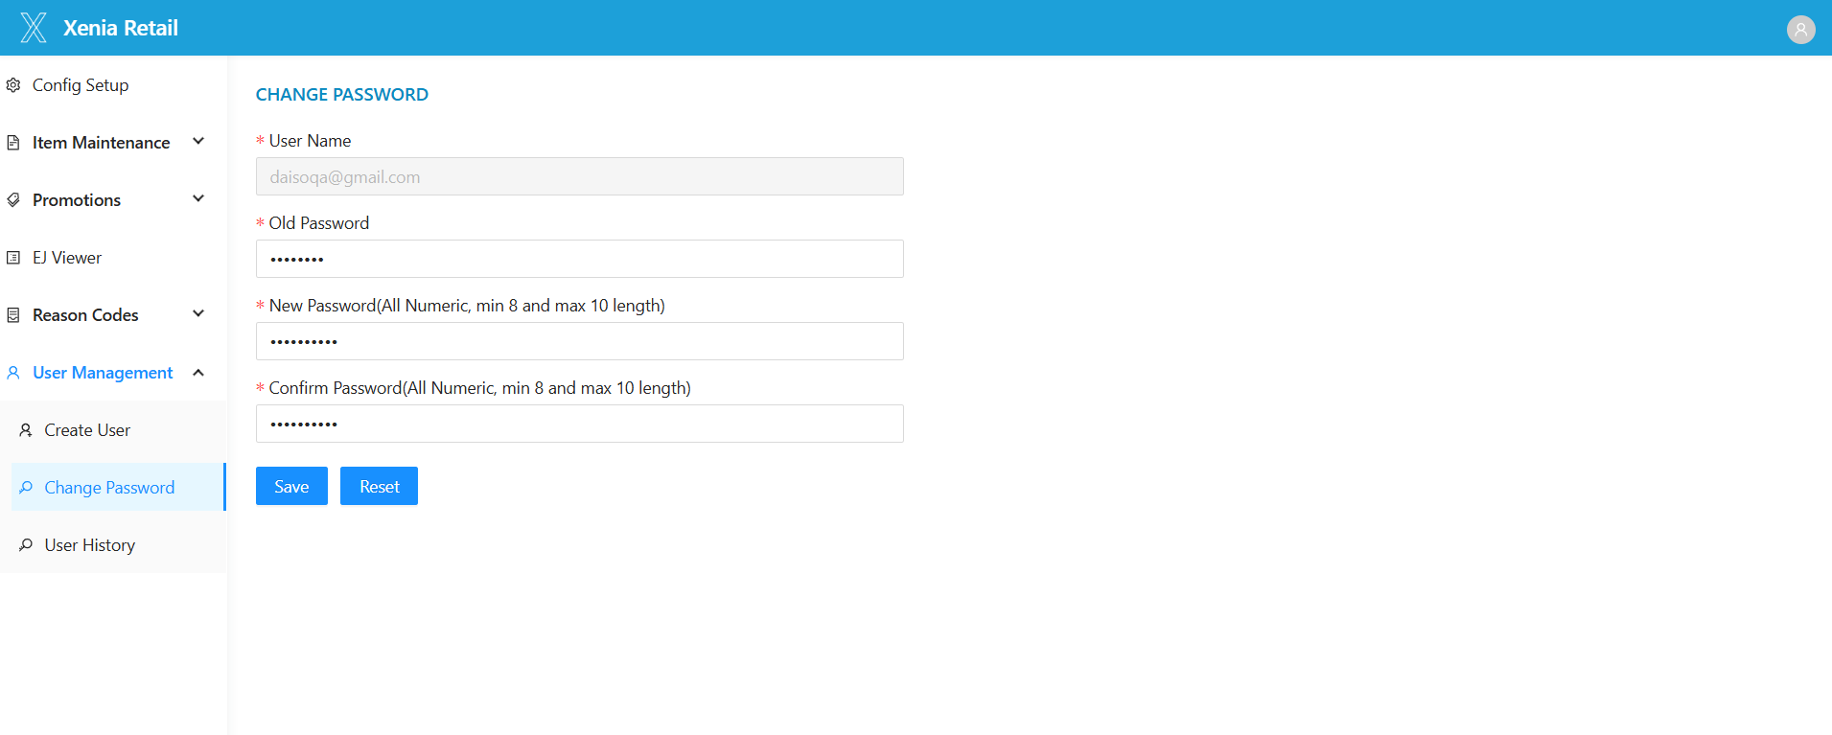
Click on Save to update the password or Reset to clear the fields.
Password will be changed successfully. The user can now log in with the new password.
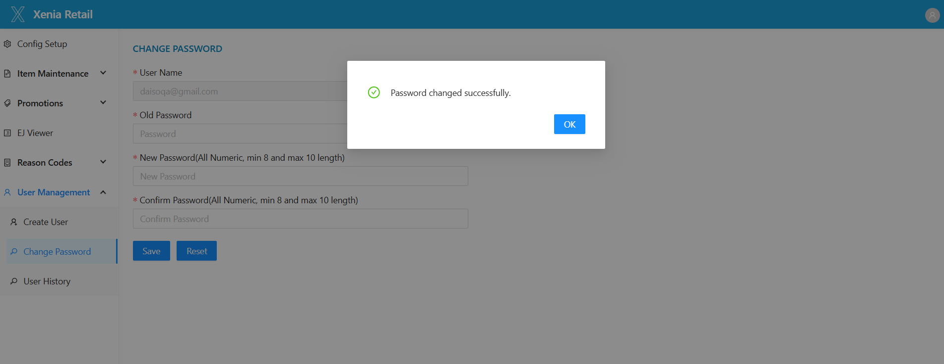

2.2.3 User History
Click on User History.
You will see a list of all created users by default.
The table will show: Username, First Name, Last Name, Role Name, Hire Date, Termination Date, Action (Activate / Deactivate)
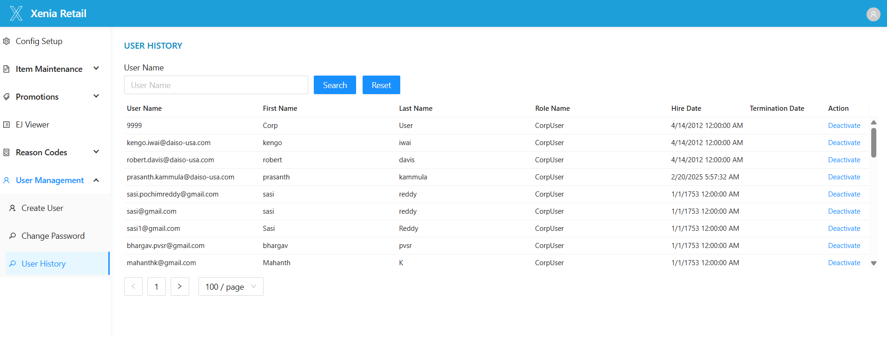
To find a specific user:
- Enter the Username in the search field and click Search.
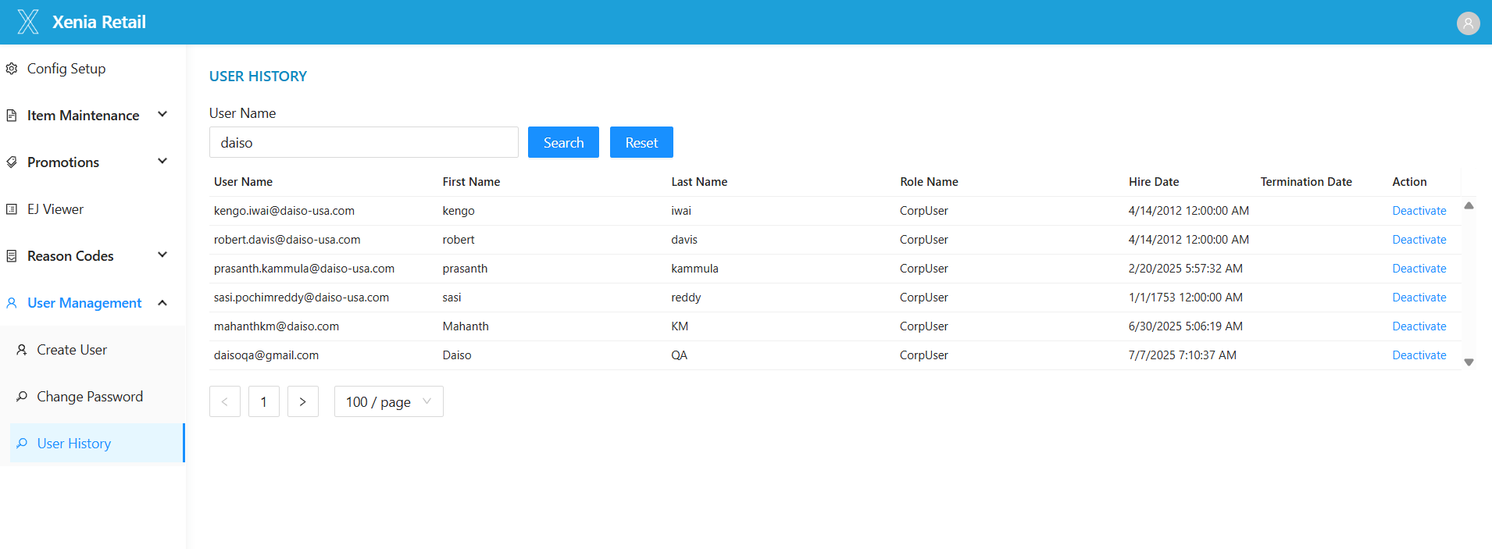

Actions:
- Deactivate: Disables the user. The Termination Date will be shown, and the user cannot log in to XCO.
- Activate: Enables the user again. The user will be able to log in.
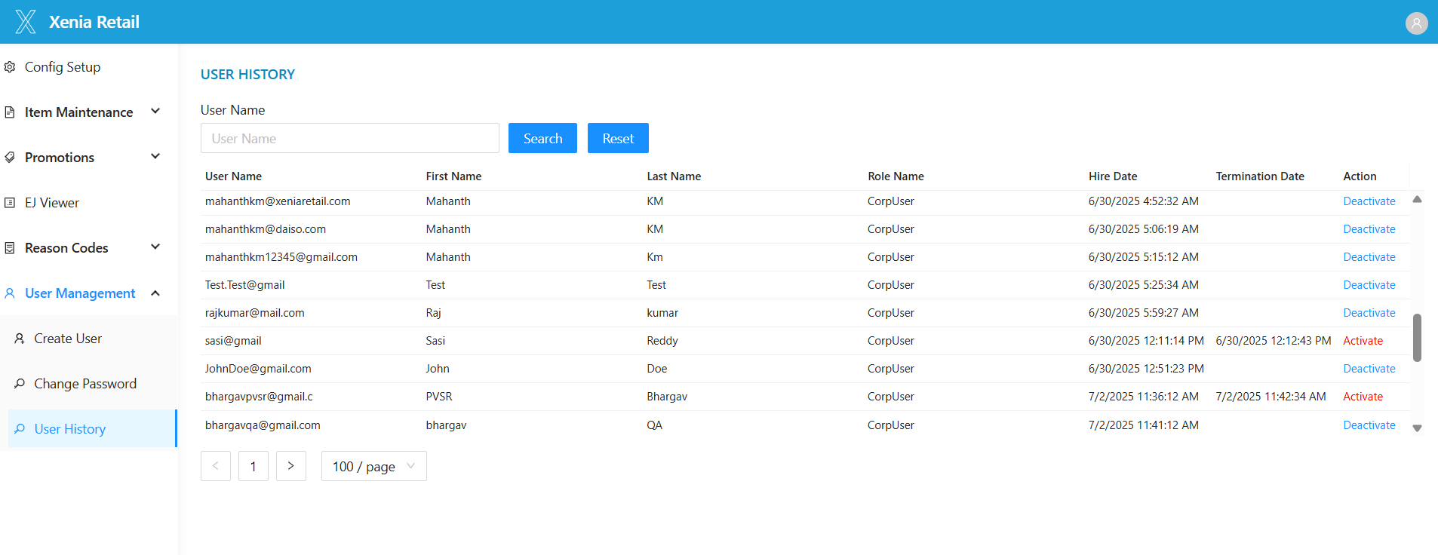

2.3 Logout
1. To log out, click the Log Out icon at the top right of the screen.
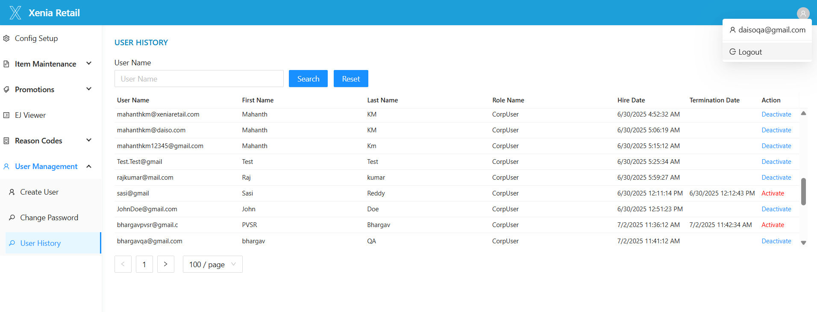

2. The system will log you out and return you to the XCO.

